ASK 2020

This is a test to evaluate your knowledge of some aspects of academic skills.
Please use the 30 min allotted to complete this.

This does not count towards your assessment in this rotation.
The following study appeared in J Pediatr 2015: 167, 246-­‐52

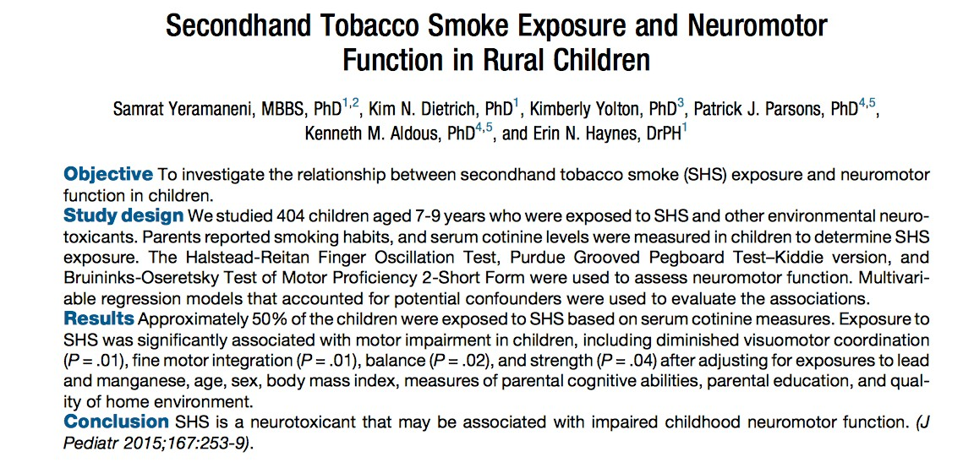

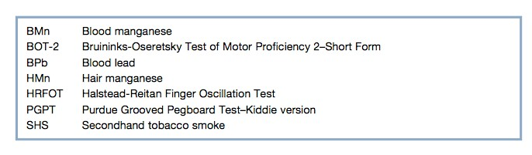

- Identify the primary exposure variable and the primary outcome variable(s)
(1 point):

_____________________________________________________________________________________________

- This is a table of Pearson correlation coefficients (r) between various exposure and outcome variables, also known as a correlation matrix. Interpret/explain the meaning of the Pearson r (1 point). Identify two limitations (2 points) of this measure

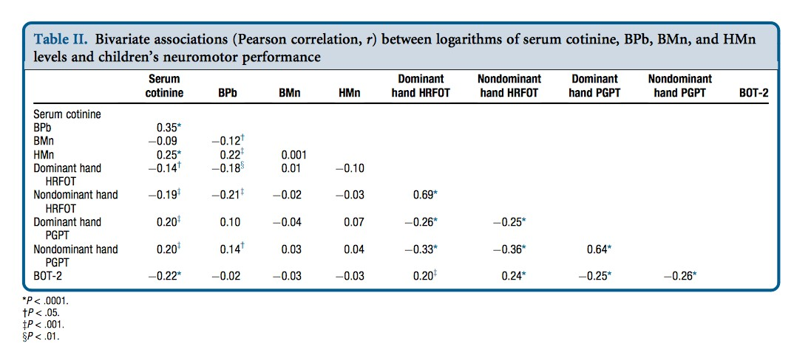

This table contains the results of multivariate linear regression where the outcome variables are various neuromotor subscores (for simplicity, we’ve left only two sets visible). Serum cotinine is measured in ng/ml, age in years, and the reference level for sex (a 0/1 categorical variable) was set as female = 0.

- Explain the meaning of the betas (partial regression coefficients) (1 point).

_________________________________________________________________________________________________________

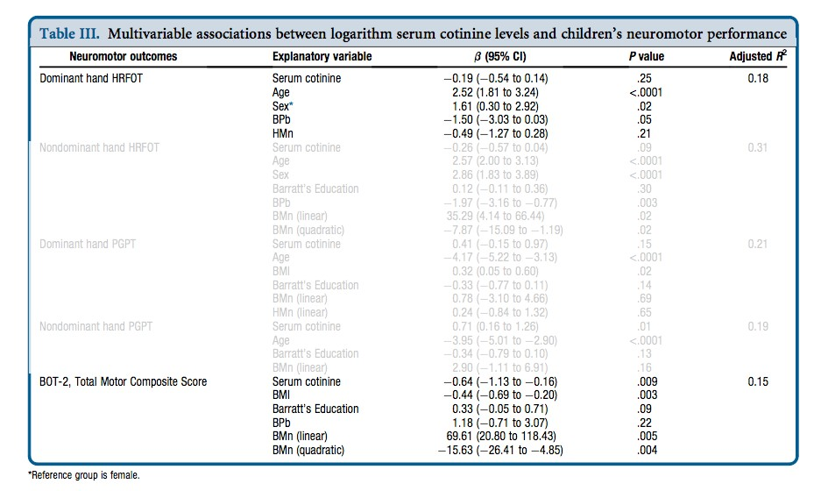

Explain the meaning of the 95% confidence intervals (1 point):

_________________________________________________________________________________

Explain the meaning of the p-­‐values (1 point):
_______________________________________________________________________
4) Explain the difference between statistical significance and clinical significance (1 point)?

5) Does this study provide evidence in support of a causal association between household exposure to second-­‐hand smoke and neuromotor outcomes (1 point):

________________________________________________________________________________

6) What is a confounder (1 point)?

_______________________________________________________________________________
Explain how the 23.3% rate of maternal smoking throughout pregnancy (Table 1, not shown) is a potential confounder (1 point)?

________________________________________________________________________________

7) Name 3 features of a solid research supervisor? (3 marks)

______________________________________________________________________________
_______________________________________________________________________________
______________________________________________________________________________

8) Name the kind of variable these are? (4 marks)

Age:___________________________________
Sex:____________________________________
Hypertension (mild/moderate/severe)____________________________
Race/ethnicity____________________________

9) Name 3 elements of an informed consent process (3)

______________________________________________________________________________________________________________________________________________________________________________________________________

10)
Match the phrase with its definition (2 points)

The proportion of patients who test positive actually have the disease
Negative predictive value
It is the probability of the subjects with a negative screening test do not have the disease
Sensitivity
The proportion of the nondiseased people who are correctly identified as negative by the test
Positive predictive value

The proportion of the diseased people who are correctly identified as positive by the test
Specificity

11) For each study design list 1 positive attribute and 1 draw back (6 points)

a) case-control
______________________________________________________________________________________________________________________________________________________________________________________________________
b) cohort
______________________________________________________________________________________________________________________________________________________________________________________________________

c) qualitative
______________________________________________________________________________________________________________________________________________________________________________________________________

12) Quality Improvement (QI) work describes a PDSA cycle (2 points)
What do the letters P-D-S-A stand for

13) When calculating a sample size for a project-what information do you need for a study comparing age of onset of STIs in adolescents vs. young adults? (3 points)

___________________________________________________________________________________________________
___________________________________________________________________________________________________

14) When being a small group facilitator, you are faced with a student who never answers any questions. How can you work to involve them in answering? (1 point)
________________________________________________________________________________________

15) In a manuscript, the Methods section contains important information
List 3 of the standard types of information (or subsection headings) for a Methods section (3 points)

Total 38 points

